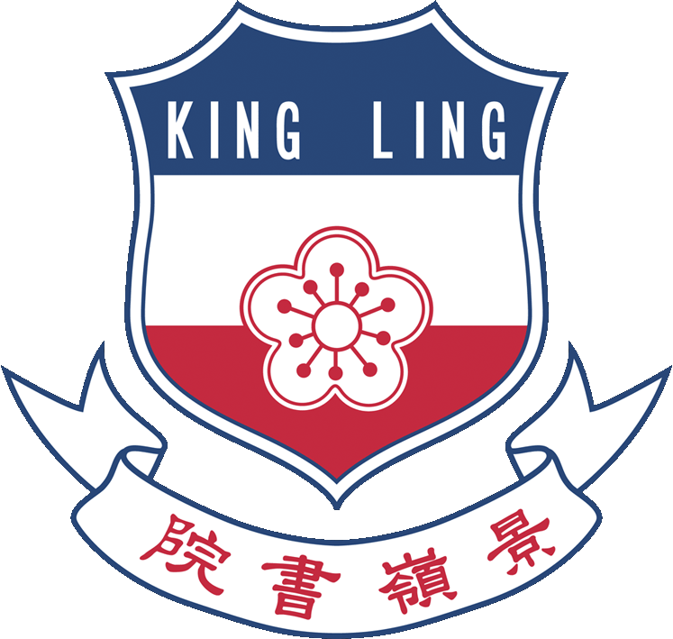

A

L1

🗶

**Construct a straight line passing through a given point and parallel to a given straight line**

**King Ling College**

**Mathematics Club**